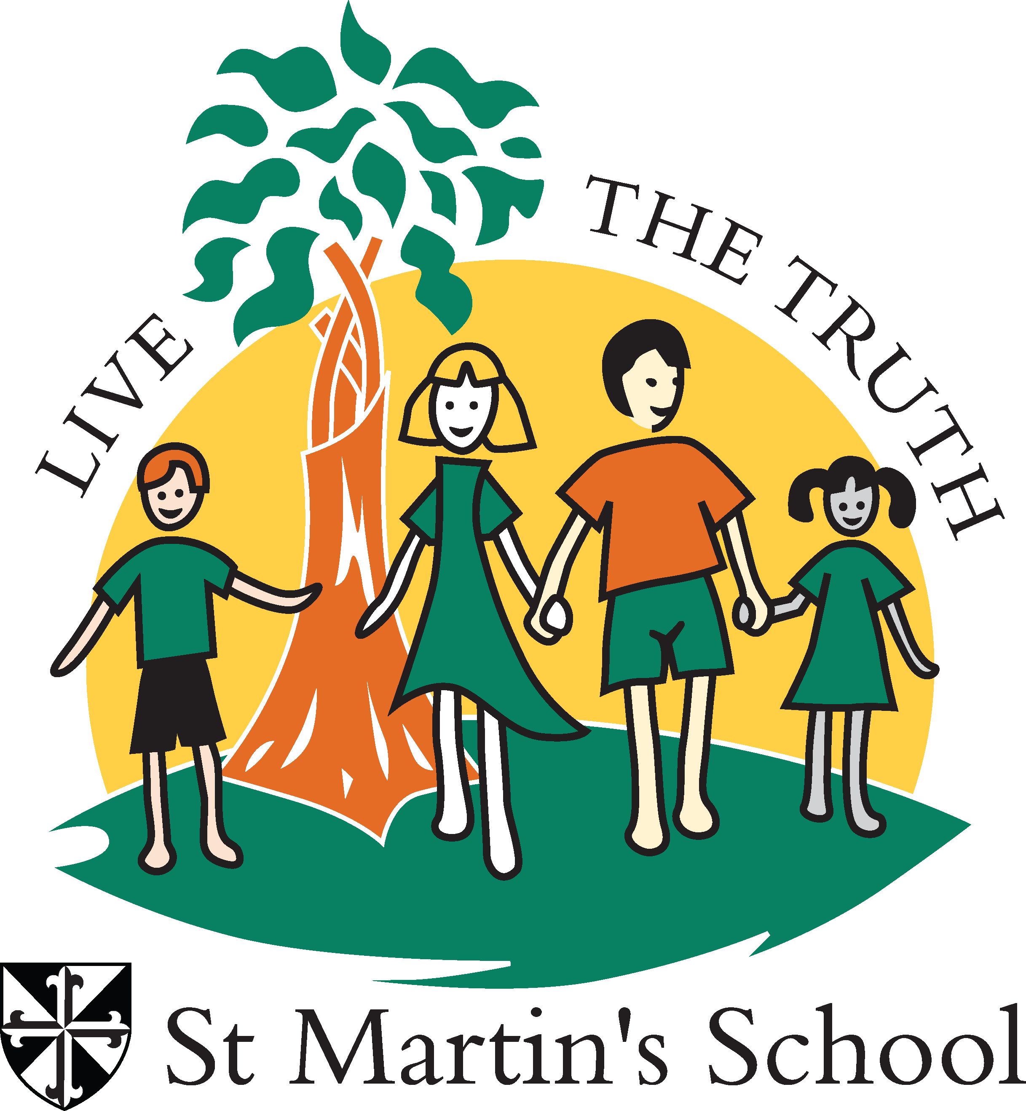
ST MARTIN’S SCHOOL
STUDENT BEHAVIOUR SUPPORT PLAN

School Mission and Vision - Teach Challenge Transform
Vision Statement
Inspired by St Martin de Porres, we are a faith-filled community who ‘Learn to Love and Love to Learn’.

Mission Statement
At St Martin’s we live our vision through our commitment to the four Dominican pillars of Prayer, Learning, Community and Service.

Pillars
- Prayer: We nurture and strengthen in our students a loving relationship with God, shaped by Gospel values.
- Learning: We educate all to be life-long learners who are empowered to shape and enrich our world.
- Service: Inspired by Jesus’ example of service to others, we act and respond with compassion
- Community: Through our words and actions, we are welcoming and inclusive, showing respect for self, others and environment.

This Student Behaviour Support Plan is designed to explicitly articulate our beliefs and practices in relation to creating and maintaining a safe, orderly and respectful learning environment. High standards of behaviour are expected, and we see these as skills that are taught and learnt both at school and home, and in partnership with parents through our Positive Behaviour for Learning matrix (PB4L). Students are expected to behave and participate positively in all aspects of their school day; both on and off campus, respecting self, others and the environment.

Our School Context
St Martin’s is a Catholic Primary School situated within the Archdiocese of Brisbane and located in Brisbane’s eastern suburb of Carina. St Martin’s school population in 2023 is 645 students from over 480 families. Our school population is generally stable and contains minimal cross-cultural students. The school has 24 classes from Prep-Year 6.
Our school staff numbers 70, with our Leadership Team consisting of a full-time Principal, a full-time APA, a full-time APRE and Primary Learning Leader. Teaching staff consists of 24 full-time classroom teachers and two part-time classroom teachers in a job share arrangement. We have specialist teachers for HPE, Art, Music/Drama, and LOTE (Italian). Our inclusion team consists of one full-time Support Teacher, one part-time Support Teacher, two part-time Guidance Counsellor and two Literacy Support Teachers. Support staff includes one part-time Teacher-Librarian, one part-time technology support person, three part time groundsman, four secretarial staff and 15 school officers. We have the services of a part-time instrumental teacher.
Our school enjoys regular attendance by its students across all year levels. Data from attendance records indicate that we have over 85% student attendance. This data suggests that generally our students are physically, socially and emotionally well.
Consultation and Review Process
St Martin’s staff developed this Student Behaviour Support Plan in consultation with our school community. A review occurs every two years with a high-level check performed annually.
Section A: Our Student Behaviour Support Systems
1. Our Beliefs and Common Philosophy about Learning and Teaching
At St Martin’s we believe that a consistent approach to learning and teaching is essential to create a unified learning community. Our vision uses the BCE Model of Pedagogy to place students at the centre of learning and teaching and to bring together the principles and the practices that we believe make a difference in improving student achievement and motivation.

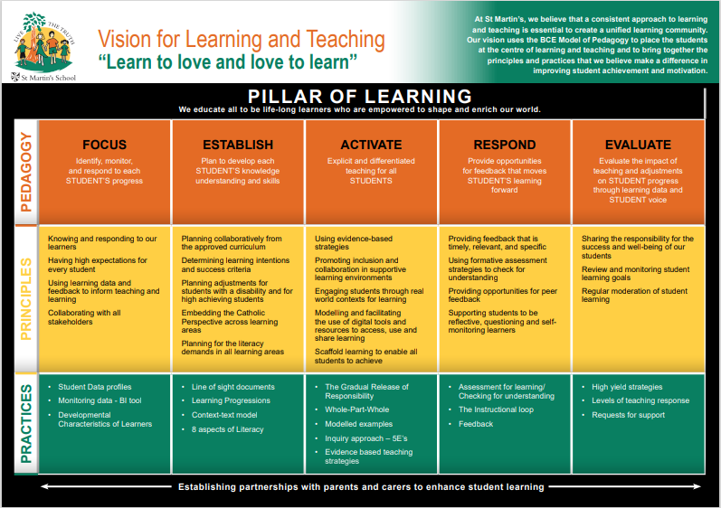

2. Our Systems Approach - Positive Behaviour for Learning (PB4L)
What is Positive Behaviour for Learning?
PB4L is a framework (Diagram 1) for schools that use a system approach to positive behaviour supports for all students. The aim of implementing the framework is to achieve increased academic and social progress and achievement for all students by using evidence-based practices. One of the focus areas is explicit teaching of behaviours that assists students to access learning – academically and socially - at all stages of development throughout their education.
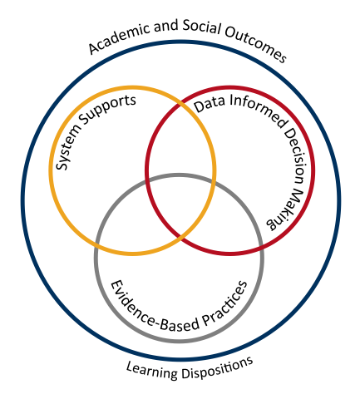
Diagram 1: Adapted from School-wide Positive Behaviour Support: implementers’ blueprint and Self-Assessment, by OSEP Centre On Positive Behavioural Interventions and Supports, 2004, Eugene OR: Lewis
Theoretical and conceptual characteristics
PB4L is the redesign of learning environments, not students. The theoretical and conceptual understandings of PB4Learning are firmly linked to Behavioural Theory and Applied Behavioural Analysis (Carr et al., 2002). This perspective emphasises that observable behaviour is an important indicator of what individuals have learned and how they operate in their environment. Environmental factors are influential in determining whether a behaviour is likely to occur, and new and alternative pro-social behaviours can be taught (Sugai & Horner, 2002; Sugai et al., 2008)
Continuum of support and key features
An important component of PB4L is the adoption of a continuum of behavioural supports (Diagram 2) that, like academic instruction, acknowledges that students will need differing levels of behavioural interventions and supports to be successful at school. Within the continuum there are three levels of support.
Tier 1 Universal Supports:
This first level focuses on universal behavioural and academic supports for all students. Here the focus is on prevention of problem behaviours, providing explicit teaching of expected behaviours and creating positive learning environments across all settings in the school. Research has shown that approximately 80-85% of students will respond to proactive universal supports, display the desired appropriate behaviours and have few behaviour problems (Horner & Sugai, 2005; Lewis, Newcomer, Trussell & Ritcher, 2006).
Tier 2 Targeted Supports:
This second level focuses on targeted supports for students who continue to display problem behaviour even with the universal supports in place. Using data analysis, students are identified early, before problem behaviours become intense or chronic, to receive targeted supports such as small group social skill instruction, academic supports, mentoring and/or self-management strategies (Sailor et al., 2013).
- Additional staff support provided
- Behaviour support and crisis management plan put in place
- Ongoing consultation with parents
- Teachers adjusted programs with differentiated workload
- Extra break times given if needed
Tier 3 Personalised Supports:
This third level focuses on personalised supports that are intensive and individualised. These students will require highly individualised behaviour support programs based on a comprehensive behavioural assessment, which at times, will include mental health professionals and family and community services.
- Additional staff support provided
- Behaviour support and crisis management plan put in place
- Ongoing consultation with parents
- Teachers adjusted programs with differentiated workload
- Extra break times given if needed
- Engagement with other professional agencies for assessments and consultations (Pedestrian, Psychologist, OT, Speech Therapist)

Diagram 2: CONTINUUM OF STUDENT SUPPORTS
Personalised or Tier 3
- Individual students
- Assessment based
- Intense, durable intervention

Universal or Tier 1
- All students
- All settings
- Preventative, proactive

Targeted or Tier 2
- Students at-risk
- High efficiency
- Rapid response

By building a connected continuum, everyone in the school is aware of how each level of support is connected to the universal systems i.e. every targeted and individualised intervention uses the universal set of behavioural expectations to increase the likelihood of maintenance and generalisation to other contexts.
3. Student Behaviour Support Leadership & Professional Learning for School/College staff
Currently, the Leadership/Support Team consists of Support Teachers, Guidance Counsellor and Leadership Team members. They meet weekly focusing on requests for support from teachers or an analysis of Engage Student Support System data.
There is a PB4L support committee consisting of teachers, support staff and a leadership representative who meet each term to support the implementation of the behaviour matrix.
Professional learning is prioritised in the professional learning plan to build capacity and sustainability.
Professional Learning is provided in the following way:
- Twilights
- Beginning of the year professional learning days
- Staff Meetings
- Staff Handbook (see Appendix C)
- Leadership structures for support: P-2 APA and 3-6 APRE
- Staff who have students with diagnosis attend professional learning to support the students within the classroom (eg. Autism training with Sue Larkey)
Staff have created a document to support the teaching of the behaviour matrix. This is regularly reviewed and updated. See appendix C
Section B: Our Student Behaviour Support Practices
1. Clarity: Our Expectations
School-wide expectations encourage consistent communications and establish a common language of expectations for all staff and students and across all settings. Agreed upon student expectations promote the school’s Catholic Identity and provide consistency across the staff and school community. The school provides all staff with a document that informs all staff of the behavioural expectations for students, that align with the Behaviour Matrix. (See appendix C)
Our school-wide expectations are:
- Respect for Self
- Respect for Others
- Respect for the Environment

Our school behaviour matrix is a visual tool that outlines the expectations of behaviours we expect all students and staff to learn, practice and demonstrate. They allow us to teach proactively and to provide students and parents with a positive message about behaviours for learning at school.
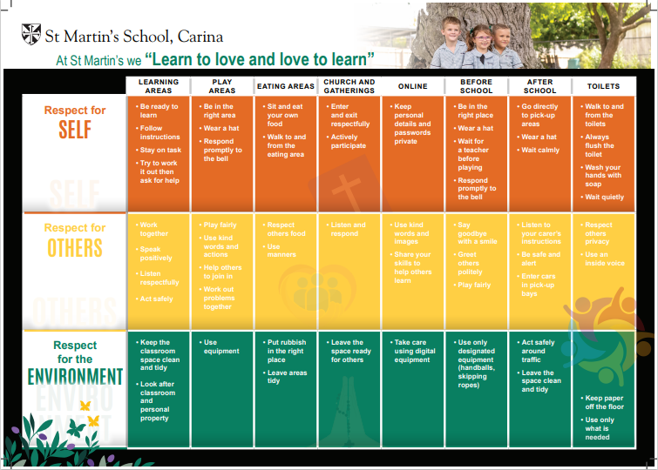

In addition to our school expectations, our curriculum is informed by the General Capabilities in the Australian Curriculum. The General Capabilities encompass the knowledge, skills, behaviours, and dispositions that, together with curriculum content in each learning area and the cross-curriculum priorities, will assist students to live and work successfully in the twenty-first century.
The Personal and Social Capability is one of the seven General Capabilities that outlines student developmental stages of self-awareness, self-management, social awareness and social management. The behavioural and social emotional skills in this capability are to be taught through the learning areas of the approved curriculum. www.acara.edu.au
Roles, Rights and Responsibilities of School Community Members
All members of our community have responsibilities in the successful implementation of our Student Behaviour Support Plan. These include:

Responsibilities of Students
At St Martin’s we expect that students will:
• participate actively in learning
• take responsibility for their own behaviour and learning
• demonstrate respect for themselves, other members of the school community, and the school environment
• behave in a manner that respects the rights of others, including the right to learn
• co-operate with others including staff and others in authority
• Demonstrate a willingness to promote behaviours that reflect the Catholic ethos as demonstrated by the role models of Jesus, St Martin and St Dominic

Responsibilities of Staff
At St Martin’s we expect that staff will:
- provide safe and supportive learning environments
• provide inclusive and engaging curriculum and teaching
• initiate and maintain constructive communication and relationships with students, parents/carers and staff
• promote the skills of responsible self-management
• model appropriate behaviours including those relating to dress and communication
- Record behaviour incidences on ENGAGE

Responsibilities of Parents
At St Martin’s we expect that parents and caregivers will:
• show an active interest in their children’s schooling and progress
• cooperate with the school to achieve the best outcomes for their child
• support the school staff in maintaining a safe and respectful learning environment for all students
• initiate and maintain constructive communication and relationships with school staff, students and parents within our community regarding their child’s learning, wellbeing, and behaviour
• contribute positively to behaviour support plans that concern their child
• model appropriate behaviours including those relating to dress and communication
• demonstrate respect of school policies and procedures including uniform policy, parking procedures, pick up and drop off procedures.

2. Focus: Teaching Expected behaviour
Effective instruction requires more than providing the rule – it requires instruction, practice, feedback, re-teaching and encouragement (Sprague & Golly, 2005). Instruction takes place each day, throughout the day, all year long. The school support document provides teachers with further information about expectations and the explicit teaching of the behaviours.
In addition, direct teaching may be done using some or a combination of the following:
- Class covenants
- Circle time in classes throughout the year
- Time built into the first weeks of schools and increased later in the year
- Assemblies followed by group practice
- Student leaders supporting younger peers
- Support from the School Chaplin
- Support from the Guidance Officer

3. Feedback: Encouraging Productive Behaviours for learning
Tier 1 Universal Supports:
Feedback should cause thinking (Dylan Wiliam, 2011). In education, we use the term “feedback” for any information given to students about their current achievements (Wiliam, 2011 p.122). Feedback to students provides them with the way to move their learning forward and make progress in their learning.
Our school uses positive feedback to encourage and motivate students, both as they are learning the expected behaviours and then to maintain those skills and dispositions as students become more fluent with their use. Specifically, our school encouragement system utilises effective, specific positive feedback, adult attention (contingent and non-contingent) and a tangible reinforcement system.
The encouragement strategies in place for school and classroom include:
School practices that
encourage expected behaviours
Weekly awards
Classroom practices that
encourage expected behaviours
Tier 2 Targeted Supports:
Targeted evidence-based interventions play a key role in supporting students at risk of academic and social problems and may prevent the need for more intensive interventions (Sailor et.al., 2009). These students consistently have trouble with low level but disruptive behaviours that interfere with instruction and hinder student learning. Targeted inventions should be timely and responsive and use similar strategies and social curriculum across a group of students.
Students are identified proactively, using academic, behaviour and attendance data accompanied by teacher nomination or through a screening process. Our targeted supports have systems in place to monitor student progress, make modifications, and gradually decrease support as student behaviour and engagement improves.

The evidence-based targeted supports currently available for students in the school include:
- The Behaviour Education Program (Check in-Check out) – (Crone, Horner & Hawken, 2004). This evidence-based Tier 2 support builds on the school-wide expectations by providing students with frequent feedback and reinforcement from their teacher/s, a respected facilitator, and the student’s parents for demonstrating appropriate behaviour and academic engagement. The goal is to move the student to self-management.
- Social Skills focussed learning. This type of intervention involves directly teaching social skills to enhance a student’s ability to interact with peers and adults. Whilst social skill instruction may be part of the work done in universal supports this type of targeted support occurs in smaller groups with students who require additional practice and feedback on their behaviour. A teacher or guidance counsellor facilitates this type of group.
Tier 3 Personalised Supports:
Successful outcomes for students whose behaviour has not responded to Universal or Targeted supports are dependent on our ability to intervene as early as possible with appropriate evidence–based interventions. A function-based approach is an essential feature of PB4L.
Personalised supports currently on offer at the school include:
- Functional Behavioural Assessment and designing an Individual Behaviour Support Plan
- Guidance Counsellor support services
- Student Support Team case management - planning and implementation of individualised support plans and monitoring data
- Partnerships with outside support agencies and specialists
4. Feedforward: Responding to Unproductive Behaviours
Even with our positive approach to teaching and supporting expected behaviours for learning, unproductive student behaviour will still occur. For some students, they do not know how to perform the expected behaviour, or don’t know it well enough to routinely use it at the appropriate times. For some students, the maladaptive behaviours they are using appear to meet their needs. When responding to unproductive behaviours, all staff take a positive, supportive approach that builds, maintains, and sustains relationships with students.
When students are sent to the office to unpack the events, a discussion occurs between the Leadership Team member and student to find out what occurred. The child is asked to reflect on their behaviour and a restorative approach is taken to restore relationships between those involved. If needed, a consequence as per the 6 Step Behaviour Support Plan is put in place. See Appendix D This document is shared with parents and uploaded to ENGAGE.
If a child requires more support within the playground to have positive interactions with their peers, extra staff may be rostered to monitor interactions.
A child may have regular check-ins with a Leadership Team member after break times to debrief the play session.

To feedforward when responding to unproductive student behaviours, we have a system in place that enables staff to respond to minor unproductive behaviours efficiently and effectively, to chronic persistent minor behaviours and to major unproductive behaviours that hinder learning. In this continuum, thinking begins with clarity between minor behaviours (that can and should be managed by teachers, within the context of the classroom and non-classroom settings) and major behaviours (that are best managed in a more private setting with the class teacher and Leadership in partnership). The definitions of teacher managed behaviours (Minor) and teacher plus leadership managed behaviours (Major) have been included in Appendix A.
Although the teacher is the key problem solver when responding to minor behaviours, they collaborate, and share creative strategies, with colleagues. Teachers respond to minor behaviours using best practices that include reminders of expectations, re-directing to learning and re-teaching behaviours. Appendix B includes a summary of practices that may be utilised.
The positive, support strategies currently in place for responding to unproductive behaviours at our school can be classified under the three evidence-based approaches recommended in BCE SBS policy and procedures, and include:
De-escalation | Problem-solving | Restorative
- Supervised calm time in a safe space in the classroom  - Supervised calm time in a safe space outside of the classroom (chillout room)  - Set limits  - Individual crisis support and management plan  - Supervised calm time on a Rainbow Seat in the playground or walking with a teacher | - Teacher – student conversation  - Work it out together plan – teacher and student  - Teacher – student – parent meeting  - Teacher – student – leadership conversation | - Student apology  - Student contributes back to the class or school community  - Restorative conversation  - Restorative conference
Refer to School Consequences/Responses for Classroom and Playground behaviours in Appendix C

5. BCE Formal Sanctions

 | When | Who nominates | Who supervises | How are parents notified?
Time out in the office | Once a child reaches Step 5  Minor violent unsafe behaviour  Repeated inappropriate behaviour that results in escalation through the steps | Teacher contacts the office to inform of student behaviour  Member of a leadership team | Member of a leadership team | Phone- Leadership  Diary- teacher
Suspension | Major violent unsafe behaviour  Verbal abuse  Ongoing and repeated inappropriate behaviour | Principal | Principal | Email to parents  Phone- Leadership
Negotiated Change of school | When a student’s continuing inappropriate behaviour and presence poses a danger to the community safety | Principal | Principal | Meeting with parents and principal
Exclusion | Serious non-compliant behaviours | Principal  School Progress and Performance Leader  Director |  | Meeting with parents, principal and School Progress and Performance Leader

For appeals, the school aligns to BCE processes.

6. Bullying and Cyberbullying – information, prevention, and school/college responses
Our Anti-Bullying Beliefs at St Martin’s:
- bullying is unacceptable; no one ever deserves to be bullied and everyone has the right to feel safe
- bullying is everyone’s concern
- all students have the responsibility to help each other make positive behaviour choices in the classroom, out in the playground and when using technology
- all adults have the responsibility to support the growth and resilience of all students and to respond to all bullying issues appropriately (as outlined in this policy)

Definition of Bullying
The national definition of bullying and harassment for Australian schools says:
Bullying is an ongoing and deliberate misuse of power in relationships through repeated verbal, physical and/or social behaviour that intends to cause physical, social and/or psychological harm. It can involve an individual or a group misusing their power, or perceived power, over one or more persons who feel unable to stop it from happening.
Bullying can happen in person or online, via various digital platforms and devices and it can be obvious (overt) or hidden (covert). Bullying behaviour is repeated, or has the potential to be repeated, over time (for example, through sharing of digital records).
Bullying of any form or for any reason can have immediate, medium and long-term effects on those involved, including bystanders. Single incidents and conflict or fights between equals, whether in person or online, are not defined as bullying. (Ref: Bullying No Way).
At St Martin’s, we agree that if you are a bystander who is involved in a bullying incident or witness bullying and do not report the incident, your behaviour could be seen as supporting the bullying.
What is NOT Bullying at St Martin’s School
It is important to identify what bullying is NOT. Dr Ken Rigby (2010) identifies that “for some people the term ‘bullying’ is a highly emotive term and its use may lead to an over-reaction.”
The National Centre Against Bullying acknowledges that while the following behaviours are often upsetting to those involved, they do NOT constitute bullying:
- mutual arguments and disagreements (where there is no imbalance of power),
- not liking someone or a single act of social rejection,
- one off acts of meanness or spite,
- isolated incidents of aggression, intimidation or violence.

Role Responsibilities
All members of our community have responsibilities in the successful implementation of our Anti-bullying policy. These include:

Responsibilities of Children
- to treat others with dignity and respect
- to understand bullying, bullying behaviours, bystanders, and cyber bullying
- to appropriately report incidents – if you believe you are being bullied, or as a bystander to a bullying incident
- as a bystander, to recognise, react and report
- to use appropriate, positive anti-bullying behaviours
- to abide the school digital citizenship contract which has been signed
Responsibilities of Staff
- to have a whole school policy that meets the expectation of the school community
- to promote a positive school culture
- to model, educate and suggest appropriate, positive anti-bullying behaviours and supportive bystander behaviours
- to use teaching and learning opportunities to address bullying
- to listen to all student reports and watch for signs of possible bullying
- to ensure that children are supervised adequately
- to respond to all reported and observed incidents of bullying as set out in this policy under Responding to Bullying. This includes identification of potential bullying by reporting through the school Incident Report. (See Appendix A.)

Responsibilities of Parents
- to support the information outlined in the St Martin’s School Bullying Policy
- to model, educate and discuss appropriate, positive anti-bullying behaviours
- to watch for signs of possible bullying
- to encourage and support your child to inform a teacher if they are being bullied or witness bullying as a bystander or speak on their child’s behalf about bullying if the child is not confident to do so
- to support the child to comply with the school’s digital citizenship contract
- have confidence that the school will take any complaint of bullying seriously through investigation and will involve parents in the ongoing support of their child if there has been a case of bullying.

Our whole-school approach to preventing and responding to student bullying and harassment
Our school uses the PB4L framework and the Australian Education Authorities resource Bullying NoWay! to assist our students, staff and school community to understand, teach, prevent and respond to bullying and harassment.

- Understanding Bullying and Harassment
At St Martin’s we provide professional learning about appropriate terminology, signs of bullying, types of bullying and research about bullying and harassment in the following way:
- Staff handbook
- Staff induction processes
- Professional development days – January
- Yearly Online modules
- Week Ahead staff newsletter
- Anti-bully days
In supporting Tier 2 & 3 students, professional development is identified as a strategy. Professional development is offered for staff working with these children. Staff may access BCE approved and offered learning opportunities or other outside organisations.

- Teaching about Bullying and Harassment
At St Martin’s we use the approved curriculum (ACARA -including the personal and social capabilities and the BCE Religious Education Curriculum) to embed the teaching of healthy relationships and positive behaviours in relation to bullying and harassing behaviours in the following ways:
- Health units/Religion units
- ICLT agreement (twice a year)
- Class covenants
- Anti-bullying days
- Productions
- Assemblies

- Responding to Bullying and Harassment
All staff must take all reports of bullying and harassment seriously and respond with a school team process.
- Listen carefully and calmly, and document what the student tells you. (Take the time to clarify with the student who has reported the incident that you have all the facts, including if there are immediate safety risks and let the student know how you will address these).
- Collect information, document and evaluate, including examples from the student/s, staff and bystanders involved.
- Contact parent/guardian to inform them of the incident, give details of the school’s immediate response, and how the incident will be followed-up. Contact appropriate school personnel (Principal and school Leadership). Always maintain confidentiality and privacy.
- Determine if this is an incident of bullying or harassment. If the incident does not meet the criteria for bullying or harassment, it can be recorded as a pastoral note in the Engage Student Support System.
- Record the incident either as Minor-Teasing or Major-Bullying/Harassment and complete the bullying record in the Engage Student Support System in a timely manner.
- Respond to incident, following the school’s student behaviour support plan. Where possible, schools should work towards a positive outcome and relationships are restored. Formal sanctions could be part of this response.
- Plan the response with the student/s and their families to provide support, teaching and strategies.
- Follow-up and gather any additional information, including data analysis on Engage Student Support System. Set a date for follow up review and monitoring.

- Preventing Bullying and Harassment
St Martin’s Proactive Anti-Bullying Strategies
Strategies to actively prevent bullying include:
- Primary Prevention Education
- Early Intervention Strategies
- Intervention Procedures
- Restoration of Well-Being

- Primary Prevention Education
Primary prevention education includes the teaching of curriculum content particular to supporting the resilience of students. At St Martin’s, we teach the ACARA General Capabilities which outline this content. These include the:
- Personal and Social Capability
- Ethical Capability

Resources that teachers use to support this teaching include:
- Circle Time
- Cyber Education through whole school and in class Digital Citizenship lessons and activities (eg.Performance Education & National Day Against Bullying)
- Parent education via the school newsletter
- Annual participation in the National Day of Action against Bullying
- Year 6 Leadership program
- Buddy programs in each year level
- School camps and excursions

- Early Intervention Strategies
Early intervention strategies include:
- ongoing monitoring of policy and practices and promotion of whole school proactive strategies by the Leadership Team.
- mapping and planning for of potential risks including geographical areas and students at risk. At times this may include changes to duty areas, additional staff allocation or running of programs for targeted students. (ENGAGE data supports this process)
- display of anti-bullying posters.
- intensive teaching and reminding of the school’s anti-bullying views at the beginning of each school year along.
- celebration of annual ‘National Day of Action Against Bullying and Violence’.

- Intervention procedures
Intervention procedures are clearly outlined in the Process of Response Section of this document. These are the procedures that occur in the event that a bullying incident is identified.

- Restoration of well-being
This includes supporting both the victim and perpetrator with educational and or therapeutic interventions in the event that they need additional support. This support may involve the teaming of the following people:
- Student, Parents, Leadership Team Members, Classroom Teacher, Support Teacher, Guidance Counsellor, outside agencies (eg.Private counsellor)

The particular supports and interventions would be articulated in the student’s individual plan; either:
    - A school-based Action Plan,
    - An Individual Behaviour Support Plan.

Key contacts for students and parents to report bullying
Staff member Principal – Peter Pashen – 3900 9100
Staff member Assistant Principal – Kylie Anderson – 3900 9100
Staff member Assistant Principal Religious Education – TBA – 3900 9100

Cyberbullying
Cyberbullying is treated at St Martin’s School with the same level of seriousness as direct bullying.
It is important for students, parents and staff to know that BCE Principals have the authority to take disciplinary action to address student behaviours that occur outside of school hours or school grounds. This includes cyberbullying. In addition, parents and students who have concerns about cyberbullying incidents occurring outside of school hours should immediately seek assistance through the Office of the e-Safety Commissioner or the Queensland Police Service.

Process for Responding to Bullying at St Martin’s (Appendix A)
When a bullying incident is reported or observed the following steps will be taken. This process may be accelerated according to student age and the seriousness of the incident.
By victim, bystander, parent or other
to the classroom teacher.

- Potential Bullying is Reported

3a) Note: If behaviour is violent OR criminal, leadership members will proceed in consultation with one or more of the following:
- BCE Senior Leader – School Progress & Performance,
- BCE Legal Counsel,
- BCE Student Protection Consultants,
- Outside agencies such as but not limited to The Queensland Police.
3. Classroom teacher reports the potential bullying to their assigned administration member: Principal, AP, or APRE.
Leadership Team Member will:
- investigate students’ records
- speak to relevant staff e.g. class teacher, Guidance Counsellor, Support Teacher etc.
- record details ENGAGE.
- inform parents if bullying has occurred. If not bullying,
- continue to monitor the situation, continue to provide support when appropriate

4. If bullying continues OR Leadership Team member feels a student requires extra support…
5. Relevant staff and Principal meet with parents of student/s exhibiting bullying behaviour. Together determine goals and consequences in line with the Brisbane Catholic Education Behaviour Support Policy via a school based Individualised Behaviour Plan.

5. Relevant staff and Principal meet with parents of the student/s victimised. Strategies for empowerment and resilience formed and set goals in line with the Brisbane Catholic Education Process “What If I have a concern about a learner?” via a school-based Action Plan.
Guidelines:
Has the child been hurt or harmed?
Is there a power imbalance?
Have there been repeated incidents resulting in hurt or harm?

NOT BULLYING- Support students via appropriate teaching and the Behaviour Support Policy and Guidelines.
2. Classroom teacher determines whether the report initially meets the guidelines and completes an ENGAGE entry.

Relevant staff, parents, student/s review progress and goals at
agreed intervals.

Relevant staff, parents, student/s review progress and goals at agreed intervals.

How Will the School Respond to Cyber-bullying?
When a cyber-bullying incident occurs, students are advised to tell an adult immediately. In this instance, staff will follow the Responding to Bullying Process outlines above.
If it is reported to the school, the school will assist to review the report and take appropriate action.
St Martin’s advises parents to report any cyber bullying or suspicious activity on the internet to the relevant authorities. For further information please refer to Homepage | eSafety Commissioner or contact your local Queensland Police station.

Evidence-based anti-bullying programs use to support students and teachers at St Martin’s

The Australian Curriculum provides the framework for our school's anti-bullying teaching and learning activities.

What is Restorative Education? What is Restorative Education | RE
Restorative Education is a social-emotional learning framework that uses evidence-based practices to teach skills that build connectedness, communication, and community stability. This strengths-based approach includes the foundations of restorative practices, is aligned with the CASEL framework for social-emotional learning, and is informed by the work addressing Adverse Childhood Experiences (ACEs) and strategies addressing the impact of trauma.
Implementation of the Restorative Education framework and strategies creates a predictable, secure, trusting climate that establishes a sense of safety and well-being. This approach leverages the structure and expectations of the school experience, in-person, online, or offline. School leaders, teachers, and students will learn the language and skills to use both within structured activities and typical interactions for consistent, predictable, and positive communication. Professional learning includes how to teach and use restorative language, establishing and implementing restorative routines, structuring and holding restorative circles, and more advanced problem-solving approaches including restorative reflections and conferences. These strategies are universal, brief, and support the objective of creating a climate for learning.

What is the philosophy of the restorative approach?
At its core, the restorative approach is a philosophical shift away from the traditional, punitive approach to wrongdoing. The restorative perspective views misbehavior as an offense against relationships.

Restorative questions to respond to challenging behaviour Restorative practice in the classroom? (nsw.gov.au)
- What happened?
- What were you thinking at the time?
- What have you thought about since?
- Who has been affected by what you have done? In what way?
- What do you think you need to do to make things right?
- If the same thing happens again, how could you behave differently?
- What support do you need? Who can you go to for support?

Restorative questions to help those harmed by other’s actions
- What did you think when you realised what had happened?
- What impact has this incident had on you and others?
- What has been the hardest thing for you?
- What do you think needs to happen to make things right?
- Who can you go to for support?

Zones of Regulation

THE ZONES OF REGULATION: A CONCEPT TO FOSTER SELF-REGULATION & EMOTIONAL CONTROL - Welcome

A FRAMEWORK DEDICATED TO HELPING STUDENTS OF ALL AGES SIMPLIFY HOW THEY THINK ABOUT AND MANAGE THEIR FEELINGS AND STATES

Evidence of Zones of Regulations

The Zones of Regulation, written by L. Kuypers and published by Social Thinking in 2011, has sold over 260,000 copies and counting, and has been widely implemented in homes, schools, districts, and clinical practices all over the world to address social emotional learning (SEL). The creation of The Zones of Regulation was based off clinical experience, seeing a need in the field to teach skills in the realm of regulation in a way learners could connect to and apply in context, all while layering together many theories, best practices and evidence as the foundation to inform and build The Zones' framework and lessons.
The Zones of Regulation is a metacognitive framework for regulation and treatment approach that is based on immense evidence in the fields of autism, attention deficit disorders (ADD/HD), and social-emotional theories. It integrates best practices around Trauma Informed Care and mental health supports and aligns with the CASEL SEL core competencies. The Zones integrates Systemizing Theory, Central Coherence Theory and Cognitive Behavior Management. It ties in Social Thinking®, visual supports and is a tool to build self-management skills. Some of these evidence-based practices are developmental in nature, while others are related to learning-styles, concepts or characteristics important to neurodiverse populations. For further explanation on how best practices were infused into The Zones of Regulation curriculum, please see the Literature Review.
The Zones of Regulation is certainly a practice based on evidence and has shown positive, measurable outcomes across multiple studies and applications in clinical practice and school-based settings (Zones Research & Scholarly Articles Spreadsheet). Knowledge gained from research guides practice and likewise feedback from clinical practice will in turn create ongoing changes to theory and our base of knowledge. Research is an integral part of what we do, and we continue to devote efforts to furthering the depth and breadth of our evidence base.
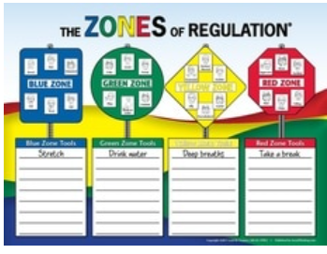

Daniel Morcombe Child Safety Curriculum
The Department of Education, in partnership with the Daniel Morcombe Foundation, has developed the Daniel Morcombe Child Safety Curriculum for Queensland students.
The Curriculum consists of classroom lessons across 3 phases of learning: Prep to Year 2 and Years 3 to 6.
The Curriculum is aligned with the Australian Curriculum: Health and Physical Education (Version 8.1) and is available to all Australian teachers through password-protected websites. It aims to teach children about personal safety and awareness, including cybersafety and phone safety, by focusing on three key safety messages: Recognise, React and Report.

Section C: Our Student Behaviour Support Data
1. Data Informed Decision Making
The BCE Engage Student Support System is the database all BCE schools are required to use to collect behavioural data for analysis and decision-making. The Engage Student Support System has capacity to record minor and major behavioural incidents so that schools can make data informed decisions about student supports. It also has capacity for schools to record, store and analyse Tier 2 Targeted and Tier 3 Personalised supports, information, and data.
It is mandatory for all BCE schools to record major incidents of bullying, weapons and drugs incidents and complete the accompanying record documentation in the system as comprehensively as possible. Suspension records are also mandatory to complete in the database.
The school uses behavioural data together with other data sources to make data informed decisions about student supports. The Support Team and Leadership Team meet every week to assess/respond to requests for support and analyse universal school data and feedback to staff meetings or team meetings.

References
Carr, E. G., Dunlap, G., Horner, R. H., Koegel, R. L., Turnbull, A. P., & Sailor, W. (2002). Positive Behavior Support: Evolution of an applied science. Journal of Positive Behavior Interventions, 4, 4-16.
Christenson, S., Stout, K. & Pohl, A. (2012). Check and Connect- Implementing with Fidelity. University of Minnesota.
Crone, D. A., Horner, R. H., & Hawken, L. S. (2004). Responding to problem Behavior in schools. New York: Guilford Press.
Greene, R.W. (2014). Lost at school: Why our kids with behavioral challenges are falling through the cracks and how we can help them. New York: Scribner.
Horner, R. H. & Sugai, G. (2005) School-wide positive behavior support: An alternative approach to discipline in schools. In L. Bambara & L. Kern (Eds.), Positive behavior support (pp359-390). New York: Guilford.
Lewis, T. J., & Newcomer, L., Trussell, R., & Richter, M. (2006). School-wide positive behaviour support: Building systems to develop and maintain appropriate social behaviour. In C.S. Everston & C.M Weinstein (Eds.), Handbook of Classroom management: Research, practice and contemporary issues (pp833-854). New York: Lawrence Erlbaum.
Newton, S. J., Horner, R. H., Algozzine, R. F., Todd, A. W., & Algozzine, K. M. (2009). Using a problem-solving model to enhance data-based decision making in schools. In W. Sailor, G. Dunlap, G. Sugai & R. Horner (Eds.) Handbook of positive behavior support (pp. 551-580). New York, NY: Springer
Sailor, W., Dunlap, G., Sugai, G., & Horner, R., Eds. (2009). Handbook for positive behavior support. New York: Springer Science and Business Media.
Sprague, J. & Golly, A. (2005). Best behavior: Building positive behavior support in schools. Boston, MA: Sopris West Educational Services.
Sugai, G., & Horner, R.H. (2002). The evolution of discipline practices: School-wide positive behaviour supports. Child and Family Behaviour Therapy, 24. 23-50.
Witt, J. C., Daly, E. J., & Noell, G. (2000). Functional Behaviour Assessment: A Step by Step Guide to Solving Academic and Behaviour Problems. New York: Sophis West.
Relevant Brisbane Catholic Education Policies
- BCE Student Protection Processes
- Management of Drug Related Incidents
- Management of Weapons in Schools
- Code of Conduct
- Student Attendance policy
- Student Diversity and Inclusion policy
- Student with Disability policy
- Student Behaviour Support policy
- Student Behaviour Support procedure
- Student, Parent and Guardian Complaints Management policy
- Student Wellbeing policy.
Appendix A - Behaviour Definitions
Minor Behaviours
 | Descriptor | Definition | Example
1 | Inappropriate verbal language | Student engages in low intensity instance of inappropriate language | Calling someone an “idiot”, swearing if they kick their toe
2 | Physical contact | Student engages in non-serious, but inappropriate contact | Pushing in the tuckshop line
3 | Defiance/non-compliance | Student engages in brief or low intensity failure to respond to adult requests
4 | Minor Disruption | Student engages in low intensity, but inappropriate disruption | Calling out, talking to a peer in class
5 | Uniform violation – Minor | Students wears clothing that is near but not within the school’s dress code | Wrong socks, wrong shorts for sport, wrong shoes
6 | Technology Violation - Minor | Student engages in non-serious but inappropriate (as defined by the school) use of mobile phone, mp3 player, camera and/or computer
7 | Property misuse | Student engages in low intensity misuse of property | Using equipment contrary to its design or purpose
8 | Late | Students arrive late to class | Tardy late to class not late to school as this is often beyond the control of a primary school student
9 | Out of Bounds | Student is in an area within the school grounds that has been designated “off limits” at that particular time
10 | Lying/Cheating | Student engages in “White Lies”
11 | Teasing | Isolated inappropriate comments (ongoing teasing would fit under bullying)
12 | Sexual Behaviour | Sexual behaviours that are normal, age-appropriate, spontaneous, curious, mutual, light-hearted, and easily diverted experimentation. | Green light behaviours
13 | Incomplete tasks | Student has failed to complete a set piece of work in a clearly specified time frame | Has difficulty starting a learning task, continuing on task, or completing learning tasks
Major Behaviours
 | Descriptor | Definition | Example/Non-Example
1 | Verbal Aggression | Language directed at others in a demeaning or aggressive manner | Swearing, aggressive stance, language directed to hurt or show disrespect, intimidating body language, intimidating tone of voice
2 | Physical Aggression | Actions involving serious physical contact where injury might occur | Hitting, punching, hitting with an object, kicking, pulling hair, scratching etc.
3 | Harassment/Bullying | Student delivers disrespectful messages (verbal or gestural) to another person that includes threats and intimidation, obscene gestures, pictures, or written notes | Disrespectful messages include negative comments based on race, religion, gender, age, and/or national origin; sustained or intense verbal attacks based on ethnic origin, disabilities or other personal matters
4 | Defiance/non-compliance – Major | Refusing request of a teacher or supervisor, talking back in an angry and/or rude manner to staff, ignoring/walking away from staff, running away
5 | Major Disruption | Persistent behaviour causing an interruption in a class or an activity | Sustained loud talking, yelling or screaming; noise with materials; and/or sustained out-of-seat behaviour
6 | Major Dress Code Violation | Student wears clothing that does not fit within the dress code of the school | “Gang” undershirts, offensive T-shirts etc.
7 | Property Damage/Vandalism | Student participates in an activity that results in substantial destruction or disfigurement of property | Throwing a computer, graffiti of school buildings, arson
8 | Skip Class/Truancy | Students leaves class/school without permission or stays out of class/school without permission
9 | Theft | Student is in possession of, having passed on, or being responsible for removing someone else’s property
10 | Forgery/Plagiarism | Student has signed a person’s name without that person’s permission (forgery). Plagiarism is submitting someone else’s work as your own. It occurs when a writer deliberately uses someone else’s language, ideas, or other original (not common knowledge) material without acknowledging its original source.
11 | Major Technology Violation | Student engages in inappropriate (as defined by school) use of cell phone, music/video players, camera, and/or computer. | Accessing inappropriate websites, using someone else’s log in details, inappropriate additions to Facebook (written and images)
12 | Use/possession of Alcohol | Student is in possession or is using alcohol
13 | Use/possession of Other Drugs | Student is in possession of or is using illegal drugs/substances or imitations or is using prescription drugs contrary to their doctor’s directions
14 | Misuse of Legal Drugs | Inappropriate use or distribution of legal drugs/medications | Intentionally overdosing of ADHD medications. Sharing around an inhaler to get a “Buzz”
15 | Use/possession of Tobacco | Student is in possession of or is using tobacco either at school or on the way to and from or at any time they are in school uniform
16 | Use/possession of Weapons | Student is in possession of knives or guns (real or look alike), or other objects readily capable of causing bodily harm
17 | Use/possession of combustibles | Student is in possession of substances/objects readily capable of causing bodily harm and/or property damage (matches, lighters, firecrackers, gasoline, lighter fluid)
18 | Bomb Threat/False Alarm | Student delivers a false message of possible explosive materials being on-school site, near school site, and/or pending explosion with the intent to disrupt school | The intent is one of a “prank” to disrupt the school day and/or Emergency Services
19 | Academic Disengagement | Student does not complete and/or submit summative assessment pieces or avoids exams | Avoiding group assignment work, minimal drafting of assessment or has difficulty engaging with learning over a period of time

Appendix B: Strategies to Manage Minor Behaviour
Technique | Explanation
Proximity | Every teacher knows how effective it is to stand near a child who is having difficulty. This technique is the strategic placement/movement by the teacher in order to encourage positive behaviour. The teacher is a source of support and strength and helps the student to control his impulses by her proximity.
Signal  Non-verbal Cue | Teachers have a variety of signals that communicate to the student what is expected. These non-verbal techniques include such things as eye contact, hand gestures, a card system, picture cues, etc. Such simple cues suggest that the teacher is aware of the student’s behaviour and is prepared to intervene if the behaviour continues. This works best when the teacher has a relationship with the student(s) and the non-verbal cues have already been taught to the group.
Ignore/Attend/  Praise | This technique is based on the power of praise or specific positive feedback. The teacher praises an appropriately behaving student in proximity to the inappropriately behaving student. The praise serves as an indirect prompt for the misbehaving student and reinforcement for the one behaving appropriately. When the student exhibits the appropriate behaviour, attention and praise is then provided.
Restitution | Involves having the student compensate for any damage that is a result of his or her actions. Restitution is required to repair any damage done, restore the environment to its original condition, or make amends to persons who were affected by the behaviour.
Re-Direct | This strategy employs a very brief, clearly and privately stated verbal reminder of the expected behaviour. A re-direct includes a specific restatement of the schoolwide, non-classroom or classroom rule/procedure. A re-direct emphasis the “what” of the behaviour instead of the “why”.
Re-teach | Re-teaching builds on the re-direct above and re-teaches the specific expectation in question and reminds of the procedures or routine for doing so. It capitalises on the teachable moment to review the expectation more thoroughly yet briefly. As in all instruction, you label the skill, teach and show, and give the student the immediate opportunity to practice demonstrating the behaviour. Once the student uses the appropriate behaviour, specific positive feedback should follow.
Provide Choice | Providing choice can be used when re-directs or re-teaching have not worked. This is the statement of two alternatives – the preferred or desired behaviour or a less preferred choice. When options are paired in this way, students will often make the preferred choice. Pause after providing the choice, and when the student chooses wisely, provide praise.
Student  Conference | This is a lengthier re-teaching or problem-solving opportunity when behaviour is more frequent or intense. The behaviour of concern is discussed, the desired behaviour is taught, and a plan is made to ensure the behaviour is used in the future. A student conference might include practice.

BEHAVIOUR MAY INCLUDE | POSSIBLE CONSEQUENCE | MANAGED BY
Step 1:  - A student infringes a class or school expectation | - Reminder of expectations | Teacher
Step 2:  - A student infringes a class or school expectation for a second time | - Name on board as a visual reminder | Teacher
Step 3:  - A student infringes a class or school expectation for a third time | - Incident is recorded and the child sits on the class ‘Thinking Chair’ for 10 mins. During this time interactions with the child cease. | Teacher
Step 4:  - A student infringes a class or school expectation for the fourth time | - Incident is recorded and the child goes to another class to sit on the ‘Thinking Chair’ for 15 minutes. During this time interactions with the child cease.  - Parent is informed via the student diary or a phone call. Teacher to check it is signed by parent. | Teacher and  Neighbouring Teacher  (Not buddy teacher)
Step 5:  - A student infringes a class or school expectation for the fifth time | - Incident is recorded in ENGAGE and the student will be sent to the office for time-out.  - The duration of time-out will be approximately 30 minutes. A small portion of this time will involve the Leadership Team member coaching the student about improving their behaviour.  - Parents will be notified by phone by the Leadership Team member that their child’s behaviour is escalating and that they will be informed about their child’s possible exclusion for the rest of the day  - Leadership Team member to record this incident in ENGAGE. | Teacher and Leadership  Team member  (Teacher to call their ‘go  to’ Leadership Team member  before sending child with a buddy. Safety first. For example, if child  is unsafe, Leadership Team member may collect child).
Step 6:  - A student infringes a class or school expectation for the sixth time | - Incident is recorded in ENGAGE.  - The student will be sent to the office.  - Parents will be notified by phone and child may be sent home.  - If the child is suspended the parents will also be informed in writing. | Teacher and Leadership Team member
Appendix C: Consequences for Inappropriate Student Behaviour in the Classroom
Note: This 6-Step Process starts fresh every day for every student.
Violent, unsafe or repeated inappropriate behaviour may result in an escalation through these steps as deemed appropriate by the Leadership Team.

Responses/Consequences for Inappropriate Student Behaviour in the Playground
Teachers use a variety of strategies to deal with inappropriate behaviour in the playground, depending on the seriousness and frequency of the behaviour. Some of these strategies include:
- A reminder about the expectation and re-teaching of the expectation
- Short period of ‘time-out’ from play on the 'Rainbow Seats' to cool down and calm down
- Longer period of ‘Time-out’ from play, remaining in the duty area eg walking with teacher or sitting in the duty area, removed from play but still supervised by duty teacher
At times when the behaviour demonstrates an escalation in seriousness or frequency, duty teachers will alert a member of the Leadership Team and request support. In these instances, an ENGAGE record will be completed by the duty teacher or Leadership Team member. Parents will be informed if their child is involved in an incident which requires support from the Leadership team.
Violent, unsafe or repeated inappropriate behaviour may result in an escalation through these steps as deemed appropriate by the Leadership Team.

Process for Appeals
Appeals by parents/caregivers are made to:
  - The Principal of the school: in relation to a decision to suspend a student for less than three (3) days. Parents/caregivers who consider that either correct procedures have not been followed, or that an unreasonable decision has been made, may appeal a suspension that is less than three (3) days to the Principal.
  - The Senior Leaders – School Progress and Performance: in relation to a decision to suspend a student for more than three (3) days from a particular school.
  - The Executive Director: in relation to a recommendation to exclude a student form a Brisbane Catholic Education School. (Executive Director, Brisbane Catholic Education, GPO Box 1201, Brisbane, QLD 4001).

Note: The fact that an appeal has been lodged does not suspend the operation of the suspension or exclusion.

In the case of exclusion, the student will be suspended pending the decision to exclude and the Principal will make an application for exclusion to the Executive Director, through the Senior Leader – School Progress and Performance. When the application has been successful and the Executive Director has agreed, the Principal will write to the parents/caregivers to notify them of the Executive Director’s decision.

If the appeal to the Executive Director is successful, consideration may need to be given to both re-instating the student’s enrolment and the conditions on which re-enrolment might occur. This will be done through discussion involving the Principal, Senior Leader and the parents/caregivers. As each situation is different, time frames for review and decision-making may differ.

Appeals must be made in writing, stating the grounds on which the appeal is being made. A parent who requires assistance to participate in the inclusive community will have access to help with the appeal process. Please see the Guidance Counsellor for referral to an appropriate person to assist with the appeal. Alternative options for responding will be considered if a written appeal is not possible.

This policy was reviewed by the Leadership Team of St Martin’s School in September 2021.

Approver: | Peter Pashen | Issue date: | 10.10.2022 | Next review date: | 13.10.2023

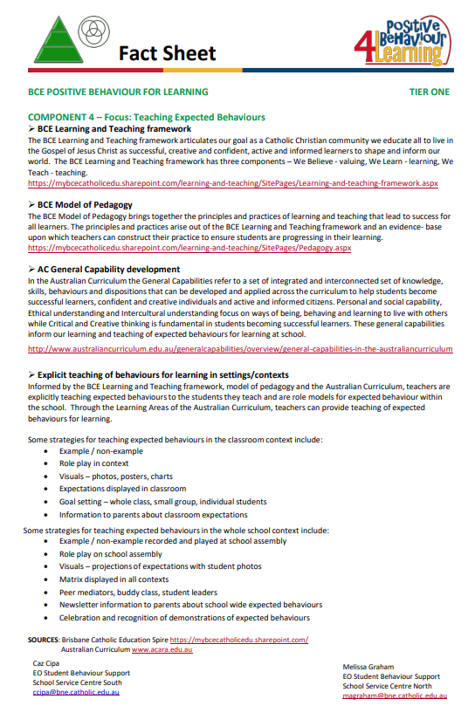

Explicit teaching of behaviours

The following document provides more detailed information about the school wide expected behaviours in each of the contexts of the Matrix. Informed by the BCE Learning and Teaching framework, model of pedagogy and the Australian Curriculum, teachers at St Martin’s use this information to explicitly teach expected behaviours to the students in their class.

Some strategies for teaching expected behaviours in the classroom context at St Martin’s include:

• Example / non-example
• Role play in context
• Visuals – photos, posters, charts
• Goal setting – whole class, small group, individual students
• Information to parents about classroom expectations

Some strategies for teaching expected behaviours in the whole school context include:

• Example / non-example recorded and played at school assembly
• Role play on school assembly
• Matrix displayed in all contexts
• Peer mediators, buddy class, student leaders
• Newsletter information to parents about school wide expected behaviours
• Celebration and recognition of demonstrations of expected behaviours

Appendix C
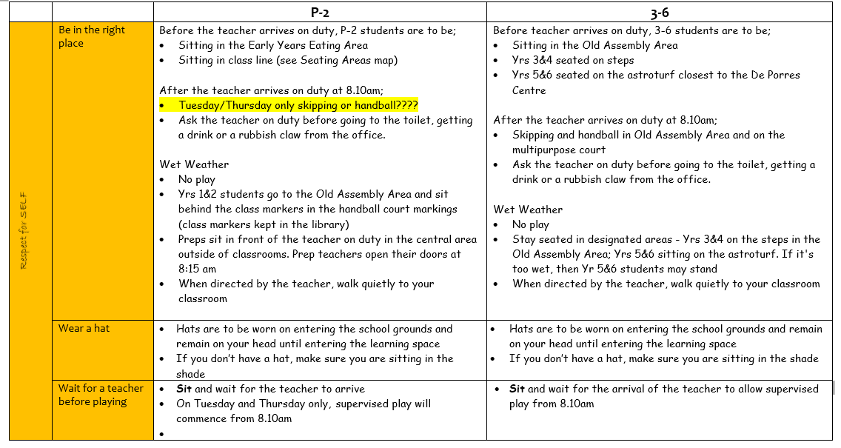
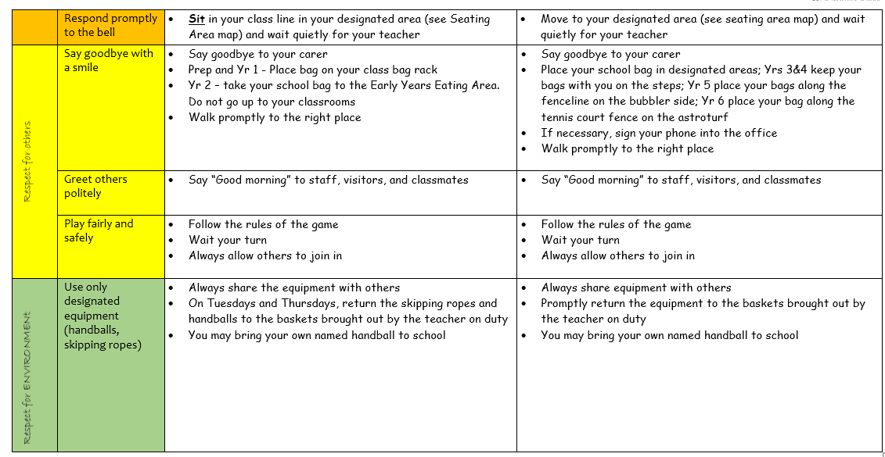
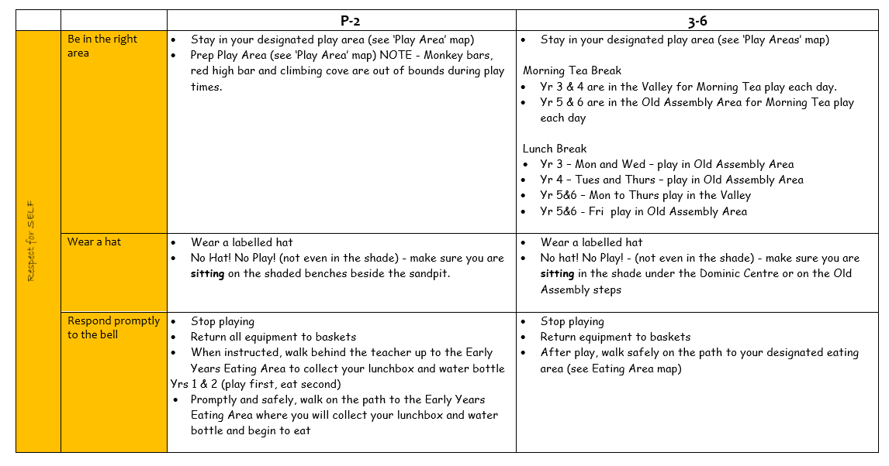
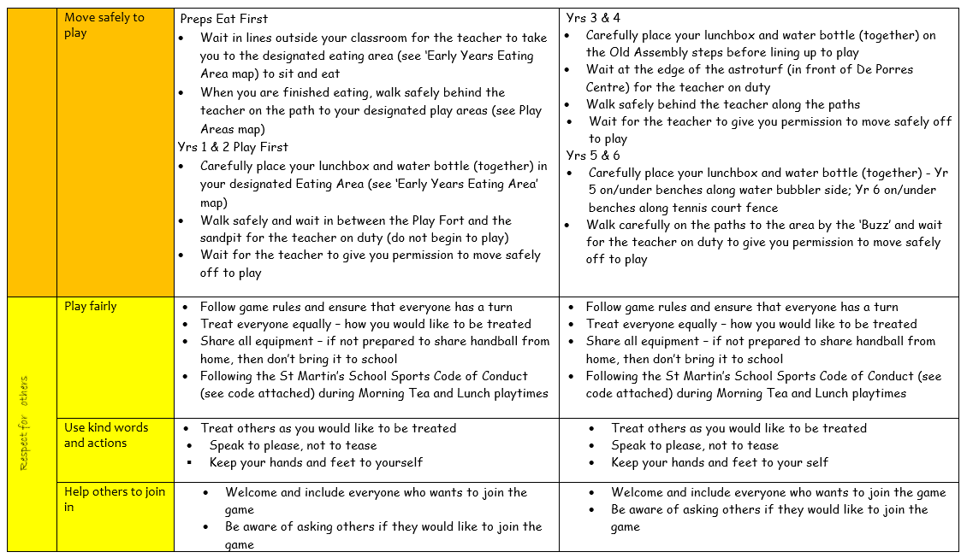
Behaviour Reflection Sheet (Appendix D)
